**Student Name:** **Weight:**

**Student ID:** **Marks:** ____/65___

**CREATE AN EMPTY DOCUMENT TO SUBMIT YOUR SOLUTIONS. DO NOT USE THIS DOCUMENT TO SUBMIT YOUR ANSWERS. YOU WILL LOSE 10% FOR DOING SO!!!**

Assignment 3: Arrays

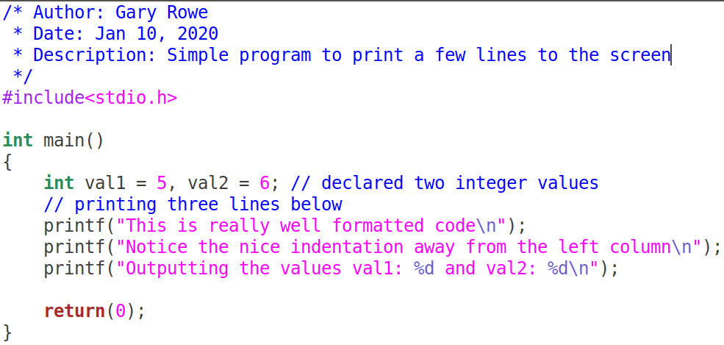Your C files should be properly ***formatted*** with ***indentations*** that enhance code ***readability***. Example of properly formatted code:

**Important:**

* On your Ubuntu VM guest machine create a folder called ITSC202.
* Inside the ITSC202 folder create a subfolder called **A3**.

A1 is the folder you will use for all the C files for **Assignment 3**.

Problem 1 (15):

You have been asked by your boss to write a program that will capitalize or title case user’s input. You **DO NOT** have access to use the **toupper** function. **Do NOT use the toupper function**.

Criteria:

* Your program should ask the user for a string of length 40 maximum.
* Your program should ask if the user wants to title case or capitalize the input
* Your program should convert the user’s input to uppercase(capitalize) or title case; based on user choice
* The user should be able to enter any character on the keyboard and have the program **ONLY** modify letters of the alphabet.
* If capitalize is chosen, but the letters are already capital, it should remain capitalized.
* If title case is chosen all except the first letter of each word will become lowercase. This means if the first letters of each word are already uppercase they will remain so.

Examples of user interaction are shown below:

[/home/newuser/assignment1/]$**./m03p01**

***Enter a sentence***: **To begin 4 days ago, I won the lottery**

***Press (a) CAPITALIZE (b) Title Case***: **a**

***Capitalized string***: **TO BEGIN 4 DAYS AGO, I WON THE LOTTERY**

[/home/newuser/assignment1/]$**./m03p01**

***Enter a sentence***: **1. o’ Canada our home and native land**

***Press (a) CAPITALIZE (b) Title Case***: **a**

***Capitalized string***: **1. O’ CANADA OUR HOME AND NATIVE LAND**

[/home/newuser/assignment1/]$**./m03p01**

***Enter a sentence***: **This WILL BecoMe tITLE CaSe**

***Press (a) CAPITALIZE (b) Title Case***: **b**

***TitleCased string***: **This Will Become Title Case**

Problem 2 (10):

You have been asked by your boss to write a program that will convert a decimal number to binary number and also print the hexadecimal value.

You can use arrays to store the calculated binary number.

Requirements:

1. Your program should print at least 8 bits for the binary number.
2. If the number is larger than 255 then you will print 12 or 16 bits (16 bits is the maximum number of bits required)
3. If the first 4 bits (known as a nibble) contains all 0’s, do not print this nibble.
4. You will also print the hexadecimal value associated with the binary value.
5. Test the user input to ensure they do not enter a number that has more bits than your array can store.

Examples of user interaction are shown below:

[/home/newuser/assignment1/]$**./m03p02**

***Enter a decimal number***: **43**

***Binary/Hex output***: **0010 1011 ---> 0x2B**

[/home/newuser/Assignment1/]$**./m03p02**

***Enter a decimal number***: **423**

***Binary/Hex output***: **0001 1010 0111 ---> 0x1A7**

[/home/newuser/Assignment1/]$**./m03p02**

***Enter a decimal number***: **45201**

***Binary/Hex output***: **1011 0000 1001 0001 ---> 0xB091**

## Question:

1. If you consider the space used by each datatype (char, short, int, float and double) what is the best choice of datatype to store the individual bits of the number entered by the user?
2. Why would you choose the datatype from question 1?
3. How many bits would be required to store the number 75000?

Problem 3 (15):

Often times you will want to copy a string from one location to another. You will write a program that copies the content of one string to another but the new string will be the reverse of the other.

**Do not use the function strlen.**

The criteria are as follows:

* Your program should get the user’s input.
* The program should reverse the entire string then
* Your program should reverse the individual words in the string and title case the final word.
* Your program should finally print the length of the string

Examples of user interaction are shown below:

[/home/newuser/Assignment1/]$**./m03p03**

***Enter a sentence***: **JavaScript is my preferred web language**

***Reversed sentence***: **Egaugnal Bew Derreferp Ym Si Tpircsavaj**

***Length:* 39**

[/home/newuser/Assignment1/]$**./m03p03**

***Enter a sentence***: **Malware Analysis is fun**

***Reversed sentence***: **Nuf Si Sisylana Erawlam**

***Length:* 23**

Problem 4 (25):

Write a program that takes a look at 2 arrays and prints out the addresses and the array elements at each of the addresses:

The criteria are as follows:

* Your program should get the user to input:
  + An integer array of 6 elements
  + A character array of 6 elements
* For both arrays, your program should print the addresses and values, both in hexadecimal.

[/home/myName/Assignment1/]$**./m01p05**

Enter Integer number 1: 345

Enter Integer number 2: 100

Enter Integer number 3: 222

Enter Integer number 4: 333

Enter Integer number 5: 456

Enter Integer number 6: 777

Enter a 6 [max] letter string : **ABcdEf**

Element Address Hexadecimal Value

================================================

Integer[1] 0xYYYYYYYY 0xXXXX

Integer[2] 0xYYYYYYYY 0xXXXX

Integer[3] 0xYYYYYYYY 0xXXXX

Integer[4] 0xYYYYYYYY 0xXXXX

Integer[5] 0xYYYYYYYY 0xXXXX

Integer[6] 0xYYYYYYYY 0xXXXX

================================================

arrChar[1] 0xYYYYYYYY 0xXXXX

arrChar[2] 0xYYYYYYYY 0xXXXX

arrChar[3] 0xYYYYYYYY 0xXXXX

arrChar[4] 0xYYYYYYYY 0xXXXX

arrChar[5] 0xYYYYYYYY 0xXXXX

arrChar[6] 0xYYYYYYYY 0xXXXX

================================================

Problem 4 Questions:

|  |
| --- |
| 1. What is the difference between the address of your Integer[1] and Integer[2]? |
| 1. What can you conclude about the size of an Integer based on the difference seen? |
| 1. What is the difference between the address of your arrChar[1] and arrChar[2]? |
| 1. What can you conclude about the size of a character based on the difference seen? |
| 1. Explain how you would calculate the number of bytes used by each array based on the output you created? |